Trade of Sheet Metalwork
Module 6: | Decorative Metalwork
Unit 2: | Copper Rose Bowl
 | Phase 2

Table of Contents
List of Figures 4
List of Tables 4
Document Release History 5
Module 6 – Decorative Metalwork 6
Unit 2 – Copper Rose Bowl 6
Learning Outcome: 6
Key Learning Points: 6
Training Resources: 7
Key Learning Points Code: 7
Forming Metals by Beating Down 9
Beating Down with Form Blocks 9
Procedure for Beating down with Form Blocks 10
Beating Down over Stakes 12
Procedure for Beating down over a Stake 13
Forming Metals by Raising 14
Raising over a Stake 14
Procedure for Raising Art Metal in Recessed Stake 15
Raising over a Sandbag 18
Procedure for Raising Metal on Sandbag 18
Self Assessment 19
Answers to Questions 1-15. Module 6.Unit 2 25
Index 36

List of Figures
Figure 1 - Rose Bowl 8
Figure 2 - Irregular-Shaped Blocks for Beating down Metal can be Sawed to Shape 9
Figure 3 - Wooden Hammers are used when Beating down Soft Metals 10
Figure 4 - Silversmith and Raising Hammers are Handy for Shaping Bowls and Trays 10
Figure 5 - In Beating down Metal you Should Work from the Centre toward the Edge 11
Figure 6 - Forming Tools made from Bowling Pin 12
Figure 7 - Beating down over Wooden Stake 12
Figure 8 - Straightening Wrinkles with a Hardwood Block 13
Figure 9 - Metal Stakes; Wood Stake and Mallet 15
Figure 10 - Estimating Stock for Raising 15
Figure 11 - A Series of Circles Serve as Guidelines 16
Figure 12 - How to use a Round Stake in Removing Dents 16
Figure 13 - Using Stake to Remove Dents from Bowl 17
Figure 14 - Using Sandbag to Shape Large Project 17

List of Tables

Document Release History
Date | Version | Comments
16/01/07 | First draft
09/04/14 | 2.0 | SOLAS transfer

Module 6 – Decorative Metalwork

Unit 2 – Copper Rose Bowl
Duration – 7 Hours

Learning Outcome:
By the end of this unit each apprentice will be able to:
- Mark out and fabricate a copper rose bowl
- Estimate blank size required
- Demonstrate procedure for annealing metal to relieve work hardening
- Use pickle solution to clean metal
- Solder legs to completed rose bowl
- Efficiently hollow and planish copper

Key Learning Points:
M D | Design and estimate blank size for bowl using formulae.
Sk | Knowledge and use of tools and equipment specific to process.
Rk Sc | Heat treatment for annealing/knowledge of work hardening.
Sk Sc | Knowledge of finishing techniques/planishing.
Rk Sk | Concentric circles method of hollowing.
P | Hammers and stakes must be smooth and polished (quality of finishing).
Sk | Even weight and overlap of hammer blows.
H | Dangers in heat treatment.
Rk | Knowledge of raising techniques.
M
Sc

Training Resources:
- Toolkit
- Tools and machinery/equipment (including bossing mallets, planishing hammers, sandbags, stakes)
- Job card
- 0.7mm half-hard copper
- Bench
- Drawing and design equipment
- Safety equipment and protective clothing

Key Learning Points Code:
M = Maths D= Drawing RK = Related Knowledge Sc = Science
P = Personal Skills Sk = Skill H = Hazards

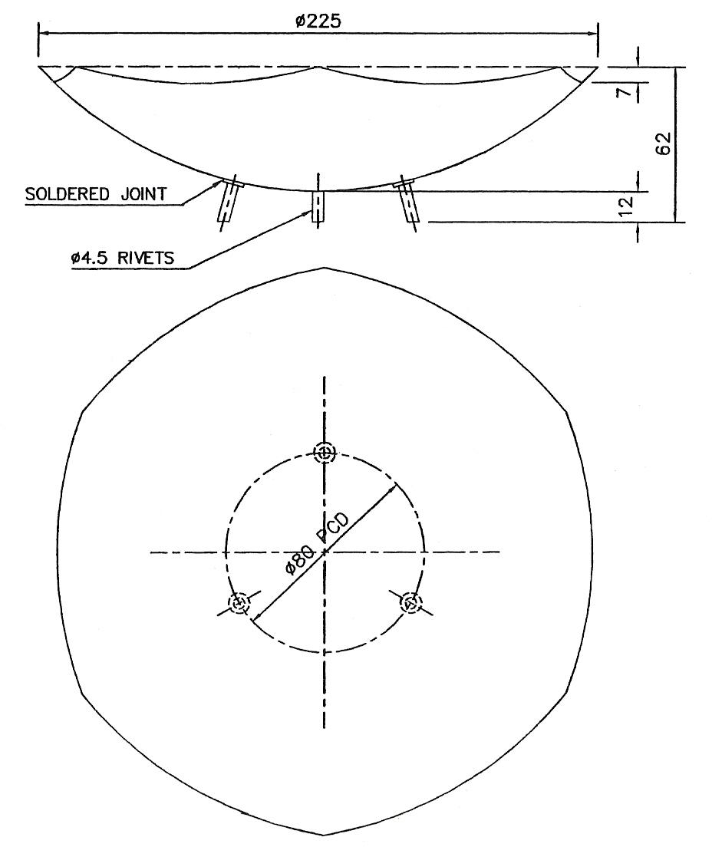
Figure 1 - Rose Bowl

Forming Metals by Beating Down
- Different ways to beat down metals.
- Tools we use for beating down.
- Type of projects which you can make by beating down.

Beating down is a forming process in art metalwork where the centre of a piece of metal is stretched to form the bottom of the object. This method of forming is generally used for shallow forming operations. Examples of projects that are formed by beating down are nut dishes, candy dishes, ash trays and plates.
Two methods of beating down art metals are with form blocks, and over stakes.

Beating Down with Form Blocks
The easiest way to beat down metal is with form blocks, Figure 2. If the item is needed in small quantity wooden form blocks are used. If the item is needed in a large quantity metal form blocks are more durable. Wooden form blocks are usually made from close-grained hardwood such as maple or birch. Choose stock free of defects and use abrasives so the surfaces of the form are smooth. When making irregular shaped form blocks like the one in Figure 2, you can use a band saw and saw the pattern from 1 inch stock. Glue this to another piece of flat 1 inch stock. Another method is to use gouges, and hollow out the desired cavity.
After making your form block, consider what kind of metal you are going to use. Is the metal soft? Is it hard to form? The size of the metal should be larger than the area of the depression in your form because some of the metal will be drawn in during the beating down process. One rule of thumb used by many art metalworkers on depressions up to 8 inch in length, is to take the longest measurement and add the depth. If your circular shape is 7 inch long and 1 inch deep, you would use metal 8 inch across. This would mean that you would have 1/2 inch of metal on each side of the depression.
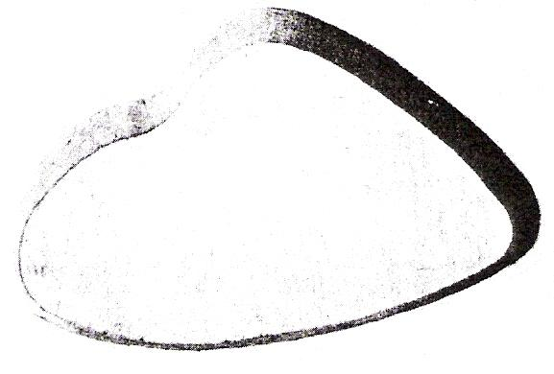
Figure 2 - Irregular-Shaped Blocks for Beating down Metal can be Sawed to Shape

Procedure for Beating down with Form Blocks
- Make the form block so the depression is the exact shape and pattern of the desired project. Round forms are easily turned on the lathe.
- Next, select and cut out the desired metal slightly larger than the area of the block, because some of the metal will be drawn down during the beating down process.
- Centre your metal on the form and fasten the metal to the form using No. 10 by 1-1/2 inch round head steel screws or 10 d nails at the corners of the metal.
- Select a hammer having the same contour as the sides of your form. When using soft metals such as pewter, zinc-based alloys and soft aluminium, use a soft hammer having a head made of wood, cellulose, horn, or rubber so you will not dent the metal. See Figure 3 and Figure 4.
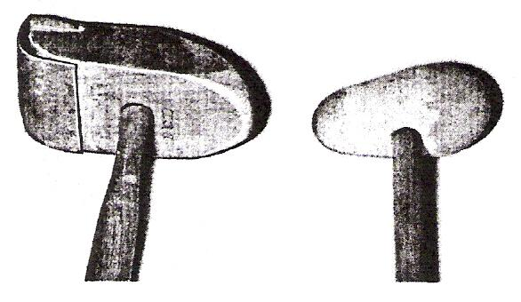
Figure 3 - Wooden Hammers are used when Beating down Soft Metals

- Place the form block on the workbench and mark the outline of the cavity with a pencil so you will know where to pound.
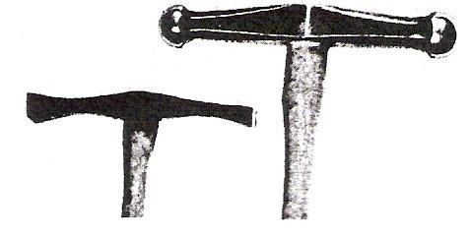
Figure 4 - Silversmith and Raising Hammers are Handy for Shaping Bowls and Trays

- Start striking the metal in the centre and then go counter clockwise toward the outside of the pattern, Figure 5.
Hit the metal in the form block so the face of the hammer strikes the metal squarely. This prevents denting the metal.
- As you strike the metal in the form block, hold your elbow close to your side and rotate the form as you hammer. The cavity should be uniform in depth and fit the mould at every surface.
- If the metal hardens during the hammering operation, you must anneal the stock. Then pickle and wash the metal before re-fastening it to the form, so you will not beat the oxide scale into the metal. Repeat the beating down process until the metal assumes the exact shape of the form.
- Remove the metal from the form and cut it to the desired shape.
- File, apply abrasives necessary to smooth scratches, and finish as desired.

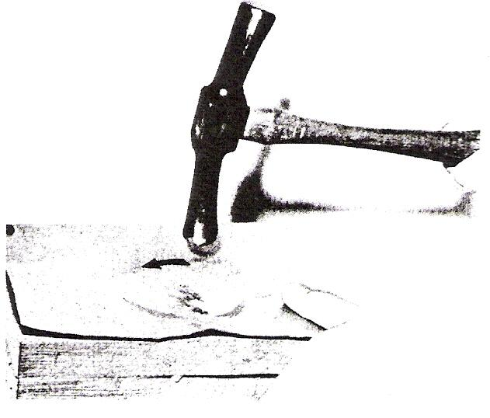
Figure 5 - In Beating down Metal you Should Work from the Centre toward the Edge

Beating Down over Stakes
Round and rectangular shallow shapes in art metal can be beaten down over stakes of wood or metal. Figure 6 shows a stake and a wooden forming mallet made from a cracked bowling pin. The hard maple from the bowling pin is durable and does not have a prominent grain that will mark the metal.
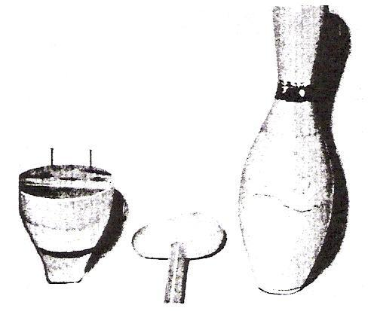
Figure 6 - Forming Tools made from Bowling Pin

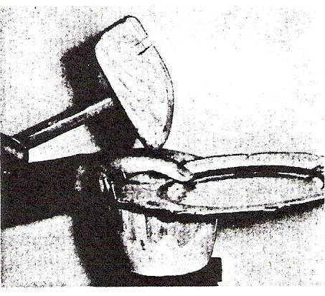
Figure 7 - Beating down over Wooden Stake
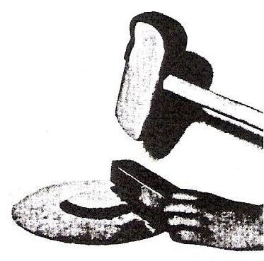
Figure 8 - Straightening Wrinkles with a Hardwood Block

Procedure for Beating down over a Stake
- Choose a stake having the shape you need for your project. This stake can be made of wood, or be a manufactured metal stake, Figure 9.
- Select and cut out your metal. Since no screws will hold the metal, additional metal must be figured when computing the amount of stock. One formula used by metalworkers is to take the longest measurement and add twice the depth.
- Put the stake on a stake table, or in a vice, and put the metal against the stake. To make a stake for beating down, cut a step identical to the depth of your project. Drive several nails in the block that will allow a uniform rim on your project.
- Choose the proper hammer and strike the metal against the step of your stake. Revolve the metal slowly in a counter clockwise position that slightly overlaps each blow. Keep your elbow close to your side when pounding.
Figure 7, shows how to beat down over a wooden stake.
- If the rim of your project develops wrinkles, straighten them immediately. Turn the project upside down and put a piece of hardwood over the wrinkles, as shown in Figure 8. Strike the block with a hammer until the wrinkle disappears. Do not let large wrinkles develop on the rim of your project as they are difficult to remove.
- Continue pounding the metal into the form until the desired depth of the cavity is reached.
- Use a smooth surface plate or other flat surface and straighten the dents in your project.
- Use the proper abrasive materials on surface defects, then after cleaning, apply the finish.

Forming Metals by Raising
- How to form metal over a stake.
- How to form metal over a sandbag.

Raising is a forming process in art metalwork where the sides of the metal are formed to give shape to the project. The bottom of the project can be either rounded or flattened.

This method will enable you to do deep forming operations on metal. Bowls and deep oval or circular trays are projects that can be raised.

The two common methods of forming by raising are forming over a stake, and forming over a sandbag.

Raising over a Stake
Stakes are flat or rounded tools used in art metalwork for various forming, raising, bending, and planishing operations. Commercial stakes come in concave, convex, and flat shapes in a great variety of sizes. Wooden stakes are used when you do not have to have a permanent tool, or, when you need a stake with a special form. Woods that are durable for making stakes include birch, hickory, and maple. See Figure 9.

To make a wooden stake for raising, obtain suitable wood and hollow out a small circular recess about 2 inches in diameter and 3/16 inches deep. The hollowing operation can be done on a lathe, or you can use woodworking hand tools. Be sure the surface of the depressed area is sanded smooth. Figure 9 shows mallet and stakes that can be used for raising soft art metals such as pewter, zinc-based alloys, aluminium and copper. Raising hammers can also be used to shape soft metals.

Procedure for Raising Art Metal in Recessed Stake
- Prepare a stake with the proper recess for your project. Use either wood or lead block for this stake.
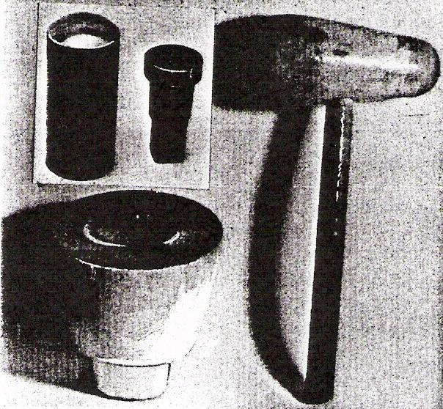
Figure 9 - Metal Stakes; Wood Stake and Mallet

- Estimate the amount of material necessary for your project. Figure 10 shows how to compute the amount of material. If the diameter of the base BC is 4 inches, the side AB is 2 - ½ inches and the side CD is 2 - ½ inches, we can add AB (2 - ½ inches) + BC (4 inches) + CD (2 - ½ inches) and we know we need stock for 9 inches in diameter. This distance can be measured with a rule, dividers or wire.
- Next, cut your disc to the proper size.
Then draw a series of circles on the disc about ½ an inch apart as shown in Figure 11.
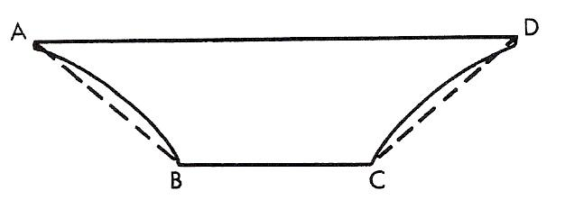
Figure 10 - Estimating Stock for Raising

- Put the outside of the disc on the recessed stake and strike on circle 1. As you strike the metal lightly with a rounded hammer, rotate the disc overlapping each stroke. Be sure to keep the metal at the same angle with the stake. Figure 12 shows how to hold the metal on the stake when raising.
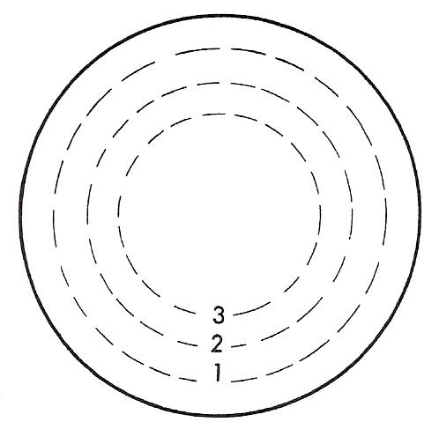
Figure 11 - A Series of Circles Serve as Guidelines

- After completing circle 1, pound the other circles in sequence.
- If the metal hardens during the forming process, anneal the metal.
Then pickle and wash the stock before proceeding.
- Lower the angle of the metal to the stake as you move toward the centre.
Use a template to check the shape of your project.
- After your project has attained its proper shape, you will want to remove dents and uneven surfaces by putting the concave surface of the bowl on a metal stake and hitting the metal with a hammer as shown in Figure 13.
Choose a stake with the same contour as your project. The metal will stretch during the forming operation.
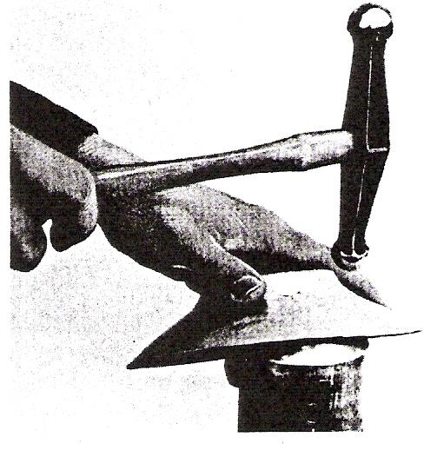
Figure 12 - How to use a Round Stake in Removing Dents
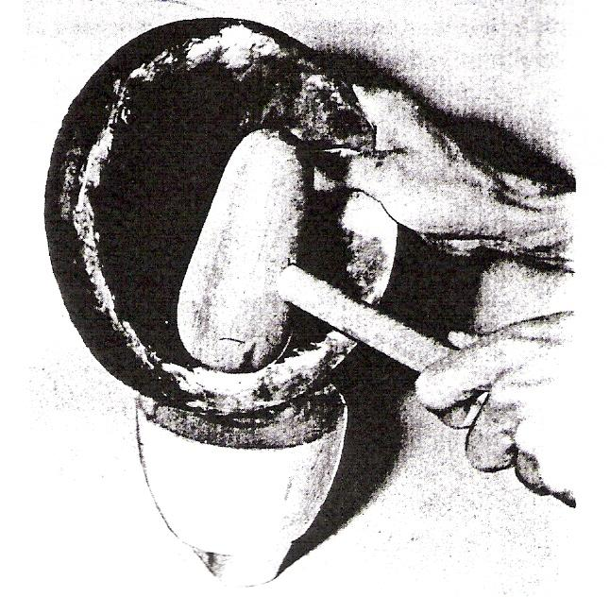
Figure 13 - Using Stake to Remove Dents from Bowl

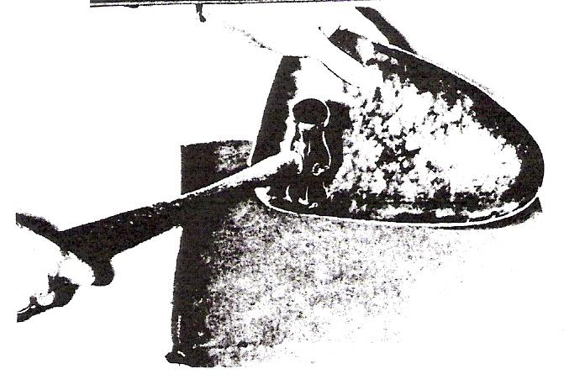
Figure 14 - Using Sandbag to Shape Large Project

- Use a surface gauge and mark the top.
Cut and file the top edge.
- Use necessary abrasives and finish your project.

Raising over a Sandbag
Sandbags are used in art metalwork to form irregular shapes, and on large projects, Figure 14. A sandbag is flexible, enabling you to make a great variety of shapes.
Sandbags should not be solidly packed. This enables you to move the sand from one area to another, and shape the bag for nearly any desired contour.

Procedure for Raising Metal on Sandbag
- Choose and cut out the metal slightly larger than your pattern to allow for shaping the edges. Use estimating formula shown in Figure 10.
- Draw guide lines on the inside edges of metal, showing where you will begin raising.
- Place sandbag on workbench or other solid surface. Flex the sandbag so you have proper contour.
- Hold your metal so it is raised about 30 deg with the sandbag, Figure 14, and begin pounding the metal against the depressed area in the sandbag. Overlap each stroke as you revolve your metal. Work slowly from the guideline toward the outer edge going in circles until your project has acquired the desired shape. Anneal as necessary being sure to remove oxide scale from the metal before re-hammering.
- After using the sandbag to shape your project, remove any surface irregularities by pounding the metal against a properly contoured stake.
- Mark the top edge with a surface gauge, and trim the top.
- Remove surface defects with the proper adhesives.
- Stands for round-base projects can be made of metal, wood, or plastic. Metal bases can be soldered in place, while wood and plastic bases can be bonded with epoxy adhesives.

Note: Decorative work involves polishing of the brass and copper items. We use polishing mops made from stitched cotton mop with Tripoli and unstitched cotton mop with rouge.

Self Assessment
Questions on Background Notes – Module 6.Unit 2

1. What does the term ‘beating down’ mean?

2. Explain how you hammer metal in a form block.

- Explain how you form a tray over a stake.

4. How would you remove wrinkles from the rim of your beaten down project.

5. Underline the correct answer.
1. The best wood for form blocks is:

a. Ash
b. Mahogany
c. Korina
d. Maple
e. Oak

2. Round form blocks are usually turned on the:

a. Band saw
b. Jointer
c. Shaper
d. Drill press
e. Lathe

3. The amount of material necessary for beating down a circular
tray 6 inch in diameter and ¾ inch deep is:

a. 6 in.
b. 6¼ in.
c. 6½ in.
d. 6¾ in.
e. 7½ in.

Complete the following sentences:

6.

The two ways you can form by raising are over a stake and
over a _________.

7.

Stakes for raising can be metal commercial stakes or stakes made
of __________.

8.

If the diameter of your raised bowl is 6 inches and the sides are
3 inches high, the amount of stock necessary is _______ inches.

9.

If your metal hardens while raising you should _________ it to
soften the metal.

10.

To remove dents from your raised bowl you can use a _________.

11.

To raise large projects, _________ are often recommended instead
of stakes.

12. What is Raising?

13. Explain how you raise metal over a wooden stake.

14. Explain how to form metal over a sandbag.

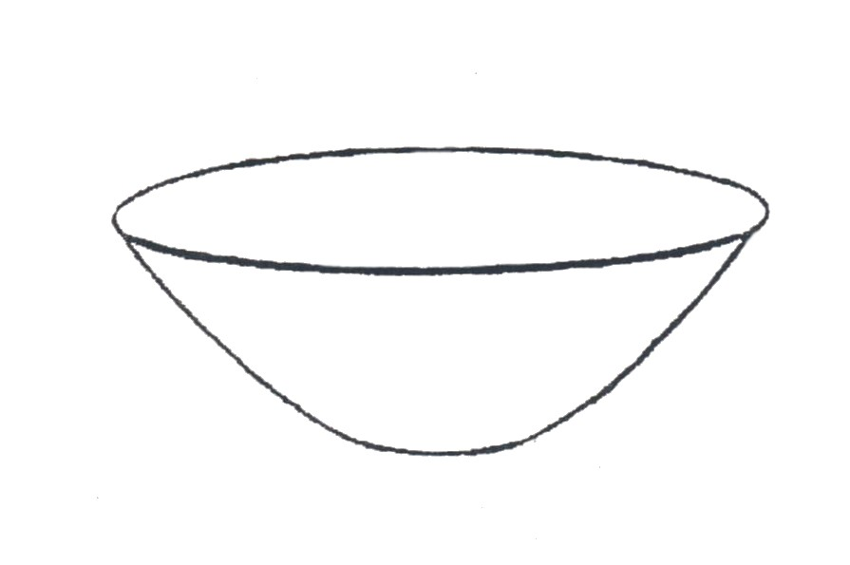
15. Draw an original base for this round
bowl?

Answers to Questions 1-15. Module 6.Unit 2
1.
‘Beating Down’

Beating down is a forming process in art metalwork where the
centre of a piece of metal is stretched to form the bottom of the
object this method of forming is generally used for shallow
forming operations such as dishes, plates and ashtrays.

2.
Procedure for ‘Beating down’ with form blocks:

a. Make the form block so the depression is the exact shape
and pattern of the desired project. Round forms are easily
turned on the lathe.

b. Next select and cut out the desired metal slightly larger than
the area of the block because some of the metal will be drawn
down during the beating down process.

c. Centre your metal on the form and fasten the metal to the form
using No. 10 by 1½ inch round head screws or 10 d nails at the
corners of the metal.

d. Select a hammer having the same contour as the sides of your
form. When using soft metals such as pewter, zinc-based alloys
and soft aluminium, use a soft hammer having a head made of
wood, cellulose, horn, or rubber so you will not dent the metal.

e. Place the form block on the workbench and mark the outline of
the cavity with a pencil so you will know where to pound.

2. Cont

f. Start striking the metal in the centre and then go counter
clockwise toward the outside of the pattern, hit the metal in
the form block so the face of the hammer strikes the metal
squarely. This prevents denting the metal.

g. As you strike the metal in the form block, hold your elbow
close to your side and rotate the form as you hammer. The
cavity should be uniform, in depth and fit the mould at every
surface.

h. If the metal hardens during the hammering operation, you
must anneal the stock. Then pickle and wash the metal before
re-fastening it to form, so you will not beat the oxide scale into
metal. Repeat the beating down process until the metal assumes
the exact shape of the form.

i. Remove the metal from the form and cut it to the desired shape.

j. File, apply abrasives necessary to smooth scratches, and finish
as desired.

3.

Procedure for beating down over a stake:

a. Choose a stake having the shape you need for your project.
This stake can be made of wood, or be a manufactured metal
stake.

b. Select and cut out your metal. Since no screws will hold the
metal, additional metal must be figured when computing the
amount of stock. One formula used by metal workers is to
take the longest measurement and add twice the depth.

3. Continued.

c. Put the stake on a stake table, or in a vice, and put the metal
against the stake. To make a stake for beating down, cut a step
identical to the depth of your project. Drive several nails in the
block that will allow a uniform rim on your project.

d. Choose the proper hammer and strike the metal against the step
of your stake. Revolve the metal slowly in a counter clockwise
position that slightly overlaps each blow. Keep your elbow close
to your side when pounding.

e. If the rim of your project develops wrinkles, straighten them
immediately. Turn the project upside down and put a piece of
hardwood over the wrinkles. Strike the block with a hammer until
the wrinkle disappears. Do not let large wrinkles develop on the
rim of your project as they are difficult to remove.

f. Continue pounding the metal into form until the desired depth of
the cavity is reached.

g. Use a smooth surface plate or other flat surface and straighten the
dents in your project.

h. Use the proper abrasive materials on surface defects, then after
cleaning, apply the finish.

4.

Straighten wrinkles as soon as they appear. turn the job over and
put a piece of hardwork over the wrinkles. Hit the block until the
wrinkles disappear.

5.

a. Maple and birch

b. Band saw

c. 6¾ inches

6.

Sand bag.

7.

Wood

8.

We add the 6" diameter to the two sides i.e. 3+3 giving a total of
12" of stock.

9.

Anneal

10.

Metal stake and hammer.

11.

Sandbags

12.

Raising is a forming process in art metalwork where the sides
of the metal are formed to give shape to the project. The bottom
of the project can be either rounded or flattened.

13.

Procedure for raising art metal in recessed stake:

a. Prepare a stake with the proper recess for your project. Use
either wood or lead block for this stake.

b. Estimate the amount of material necessary for your project.
Figure 2 shows how to compute the amount of material. If the
diameter of the base BC is 4 inches, the side AB is 2½ inches
and the side CD is 2½ inches, we can add AB (2½ inches)
+ BC (4 inches) + CD (2½ inches) and we know we need stock
for 9 inches in diameter. This distance can be measured with a
Rule, dividers or wire.

13. Continued.

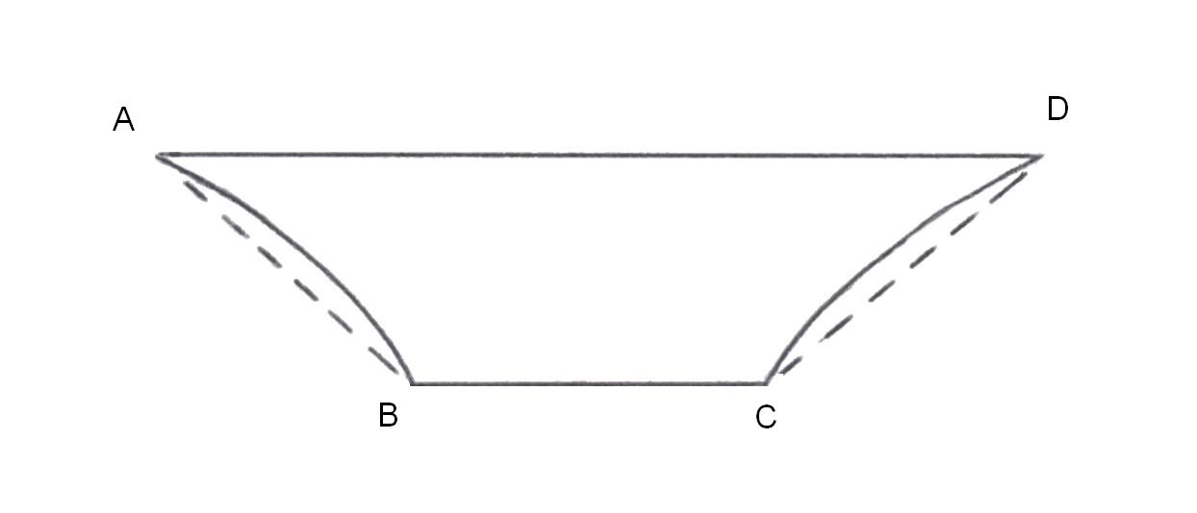

Figure 2.

c. Next, cut your disc to the proper size. Then draw a series of
circles on the disc about ½ an inch apart as shown in figure 3.

d. Put the outside of the disc on the recessed stake and strike on
circle1. as you strike the metal lightly with a rounded hammer
rotate the disc overlapping each stroke. Be sure to keep angle
of metal the same.

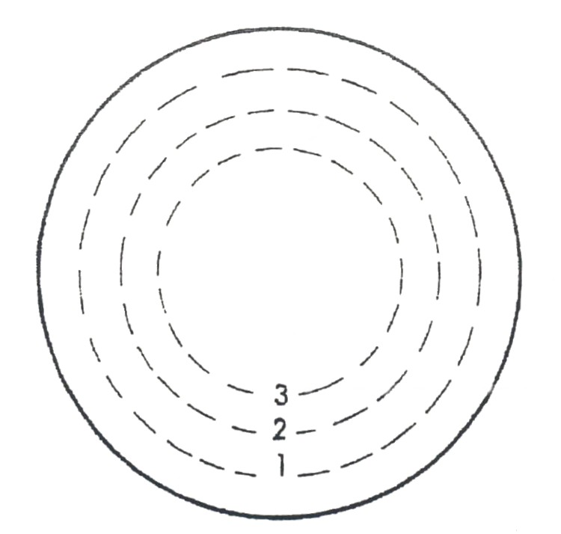
Figure 3:

e. After completing circle 1, pound the other circles in sequence.

f. If the metal hardens during the forming process, anneal the
metal. Then pickle and wash the stock before proceeding.

g. lower the angle of the metal to the stake as you move towards
the centre. Use a template to check the shape of your project.

h. After your project has attained its proper shape, you will want
to remove dents and uneven surfaces by putting the concave
surface of the bowl on a metal stake and hitting the metal with
a hammer. Choose a stake with the same contour as your
project. The metal will stretch during the forming operation.

14.

Procedure for raising metal on sandbag:

a. Choose and cut out the metal slightly larger than your pattern to
allow for shaping the edges.

b. Draw guide lines on the inside edges of metal, showing where
you will begin raising.

c. Place sandbag on workbench or other solid surface. Flex the
sandbag so you have proper contour.

d. Hold your metal so it is raised about 30° with the sandbag and
begin pounding the metal against the depressed area in the
sandbag. Overlap each stroke as you revolve your metal. Work
slowly from the guideline toward the outer edge going in circles
until your project has acquired the desired shape. Anneal as
necessary being sure to remove oxide scale from the metal before
re-hammering.

e. After using the sandbag to shape your project, remove any
surface irregularities by pounding the metal against a properly
contoured stake.

f. Mark the top edge with a surface gauge, trim the top.

g. Remove surface defects with the proper adhesives.

h. Stands for round-base projects can be made of metal, wood or
plastic. Metal bases can be soldered in place while wood and
plastic may be bonded with epoxy adhesives.

15.

Use your imagination. The base may be flat, inverted. You may
also fabricate a ring and join it to the bowl.

Index

F
Forming Metals by Beating Down, 9
Beating Down over Stakes, 13
Beating Down with Form Blocks, 9
Procedure for Beating down over a Stake, 14
Procedure for Beating down with Form Blocks, 11
Forming Metals by Raising, 15
Procedure for Raising Art Metal in Recessed Stake, 16
Procedure for Raising Metal on Sandbag, 19
Raising over a Sandbag, 19
Raising over a Stake, 15
S
Self Assessment, 20

